

Ethernet

Introduction to Networking and Security



October 13, 2019

Jamie lu

W0441213

Table of Contents

Introduction: 2

Question 3 3

Activity 5.1.1.7 3

Question 6 7

SCREENSHOT OF PC0’S IP CONFIGURATION 7

SCREENSHOT OF PC0’S IP CONFIGURATION 8

Question 7 9

SCREENSHOT OF CURRENT ARP TABLE 9

Question 8 10

SCREENSHOT OF NEW ARP TABLE 10

Question 13 11

SCREENSHOT OF NEW ARP TABLE 11

Question 14 12

Binary to Hexadecimal Conversion 12

Hexadecimal to Binary Conversion 13

Decimal to Binary Conversion 14

Question 15 15

Cheat Sheet 15

References 15

# Introduction:

This assignment contains activities that used learnings from Cisco’s CCNA R&S: Introduction to Networking: Chapters 5[1]. This assignment also contains uses the information learned and skills acquired with regards to the topics that were covered, namely, ethernet frame, MAC addresses, switches, ARP, VLANs and Trunking. This assignment also contains the continuation of the case study that was mentioned in the previous assignments. It tackles on what is needed for switch installation and configuration. This assignment also shows the skill of converting Binary, Hexadecimal, and Decimal that was learned in class.

# Question 3

## Activity 5.1.1.7

* 1. What is the source MAC address?
     + 00:0c:29:c3:a2:55

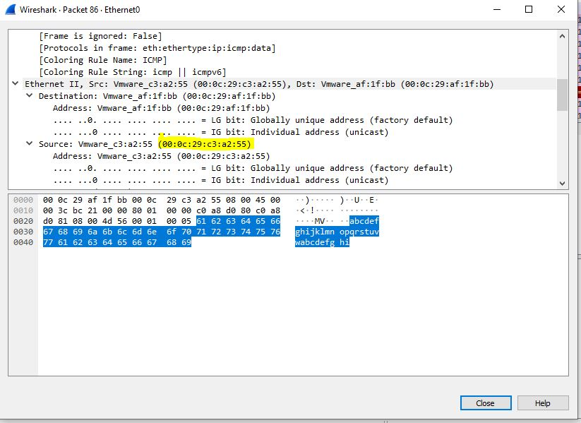

* 1. What is the destination IP address?
     + 192.168.208.129

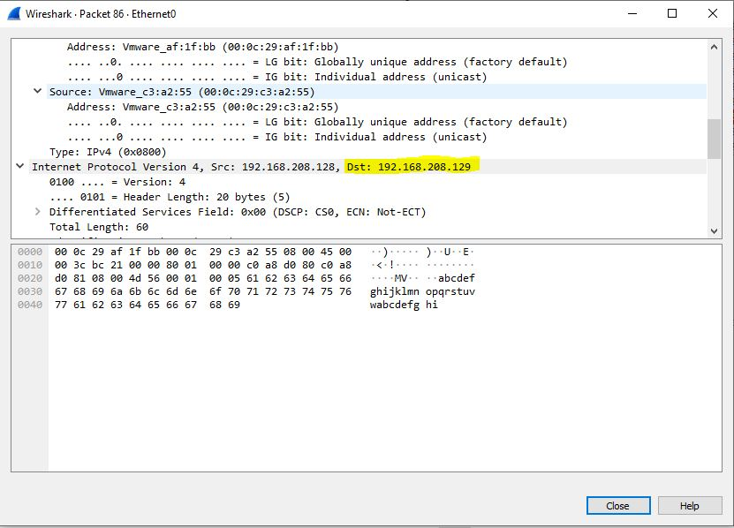

* 1. What is the frame type?
     + IPv4 0x0800

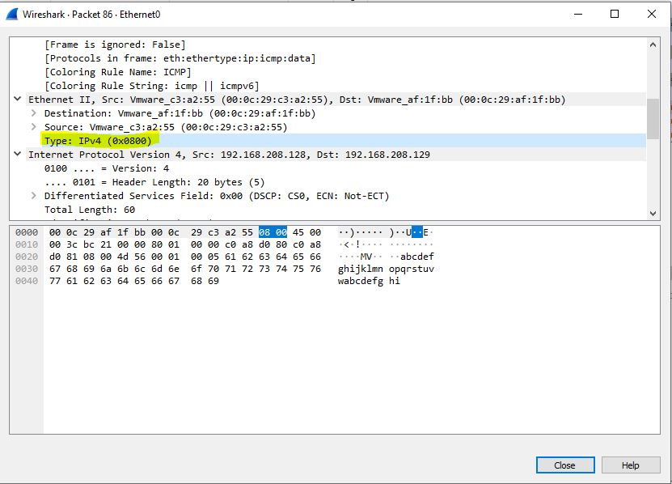

* 1. What protocol is being used?
     + The protocol being used is ICMP or Internet Control Message Protocol



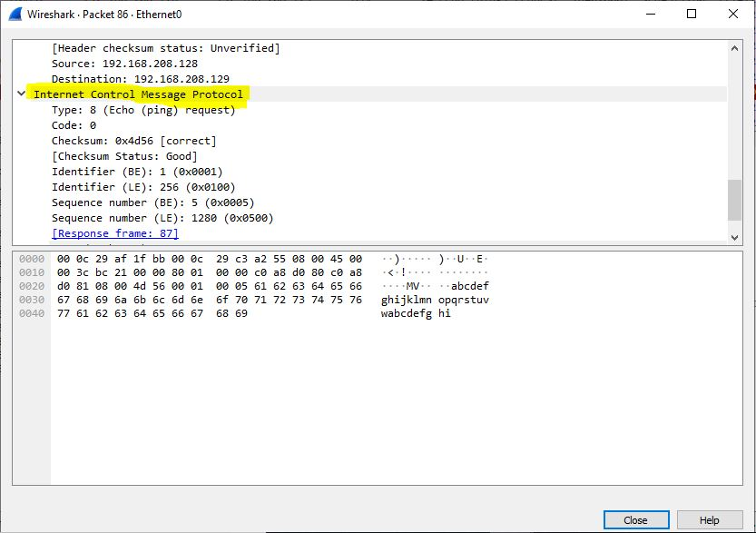

# Question 6

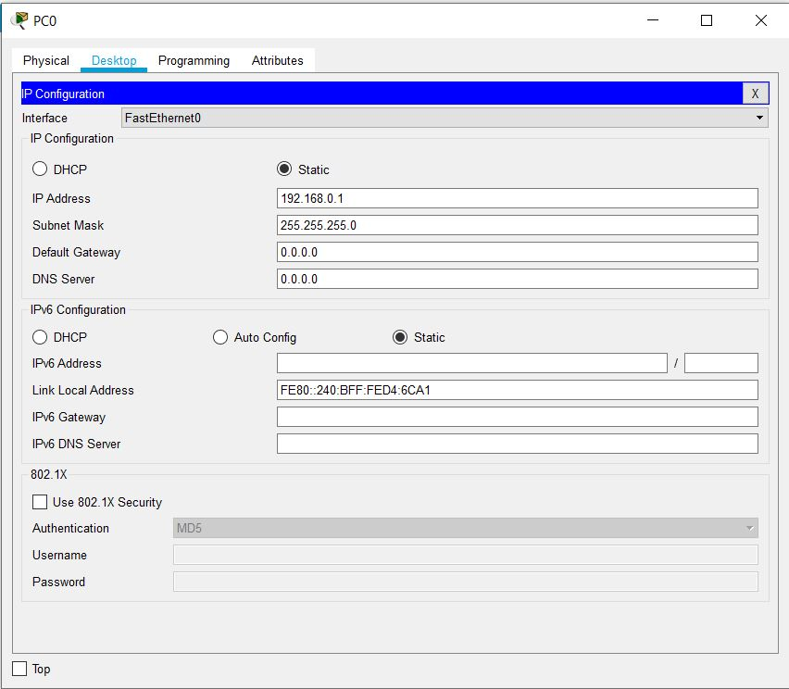

## SCREENSHOT OF PC0’S IP CONFIGURATION

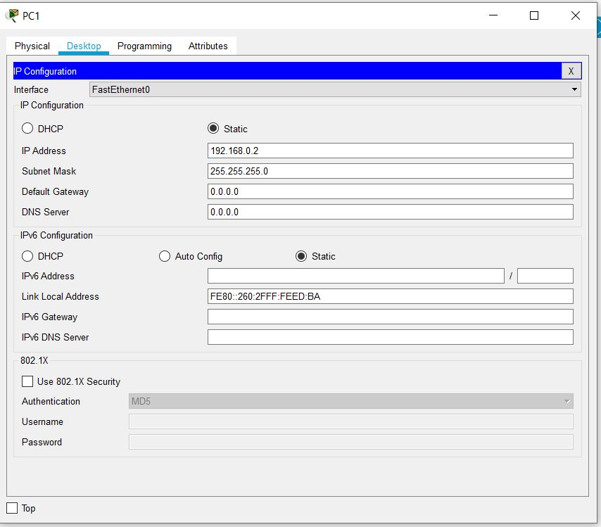

## SCREENSHOT OF PC0’S IP CONFIGURATION

# Question 7

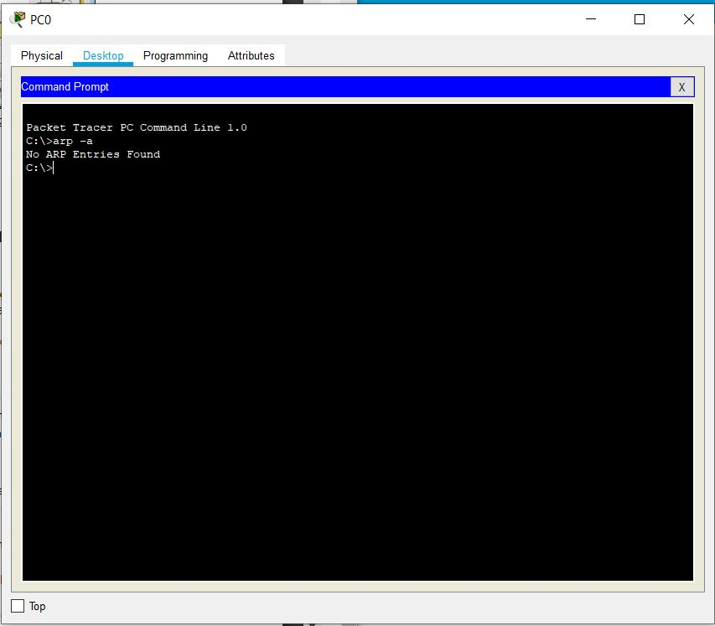

## SCREENSHOT OF CURRENT ARP TABLE

# Question 8

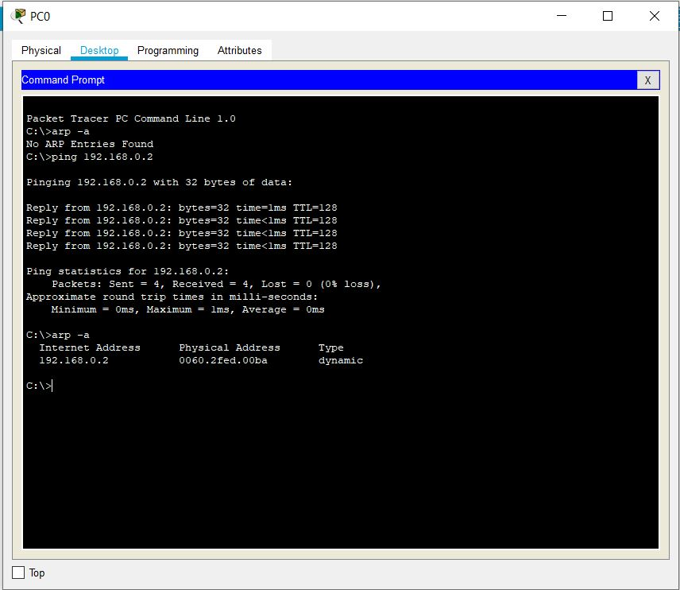

## SCREENSHOT OF NEW ARP TABLE

# Question 13

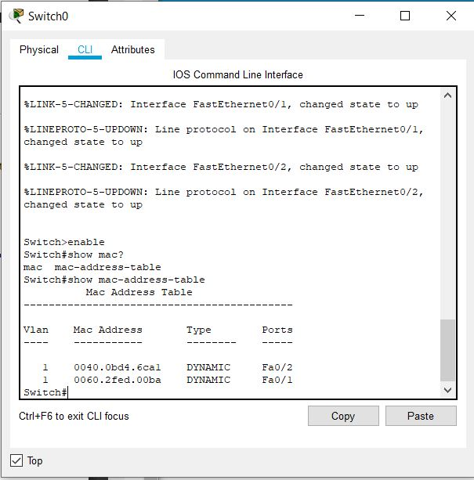

## SCREENSHOT OF NEW ARP TABLE

# Question 14

## Binary to Hexadecimal Conversion

(Solutions at the bottom)

**1100110011**

= 333

**0011010101**

= D5

**1010110011**

= 2B3

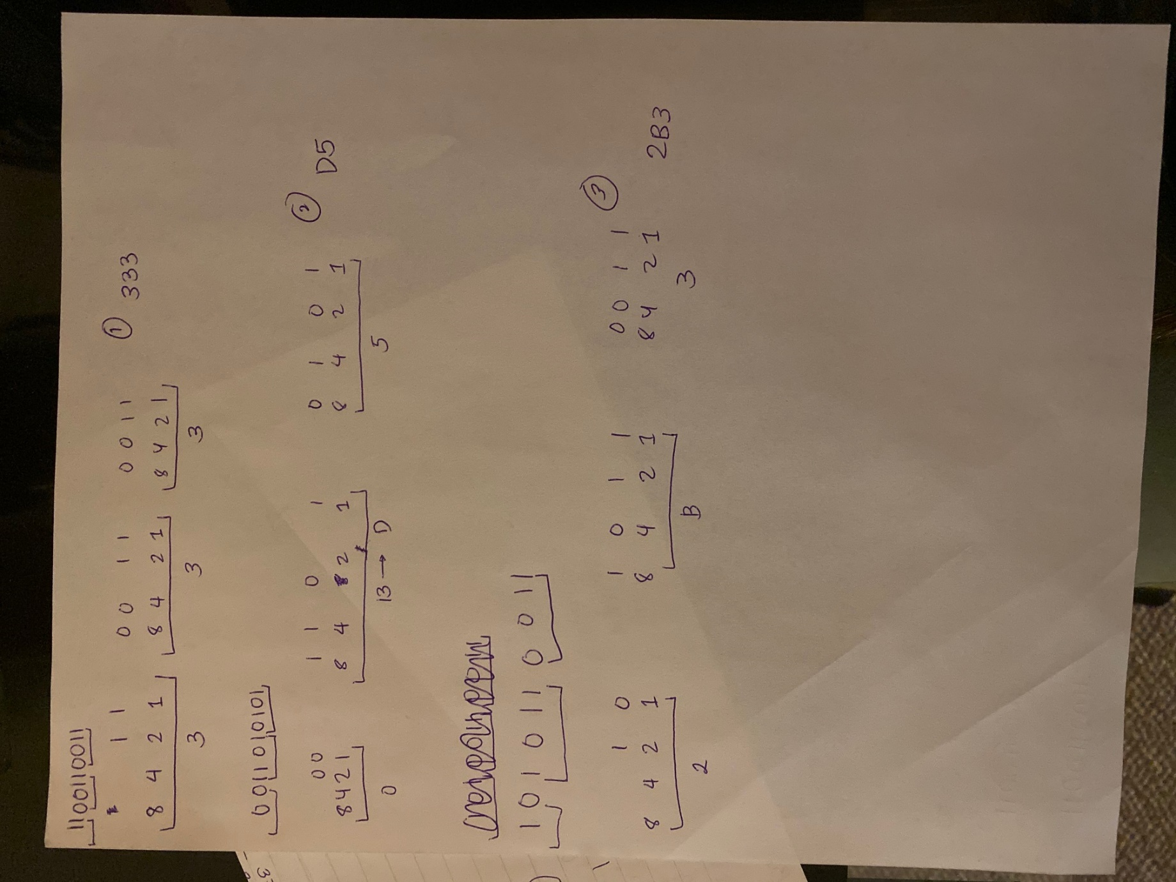

## Hexadecimal to Binary Conversion

(Solutions at the bottom)

**374**

=001101110100

**2B6**

=001010110110

**8D9**

=100011011001

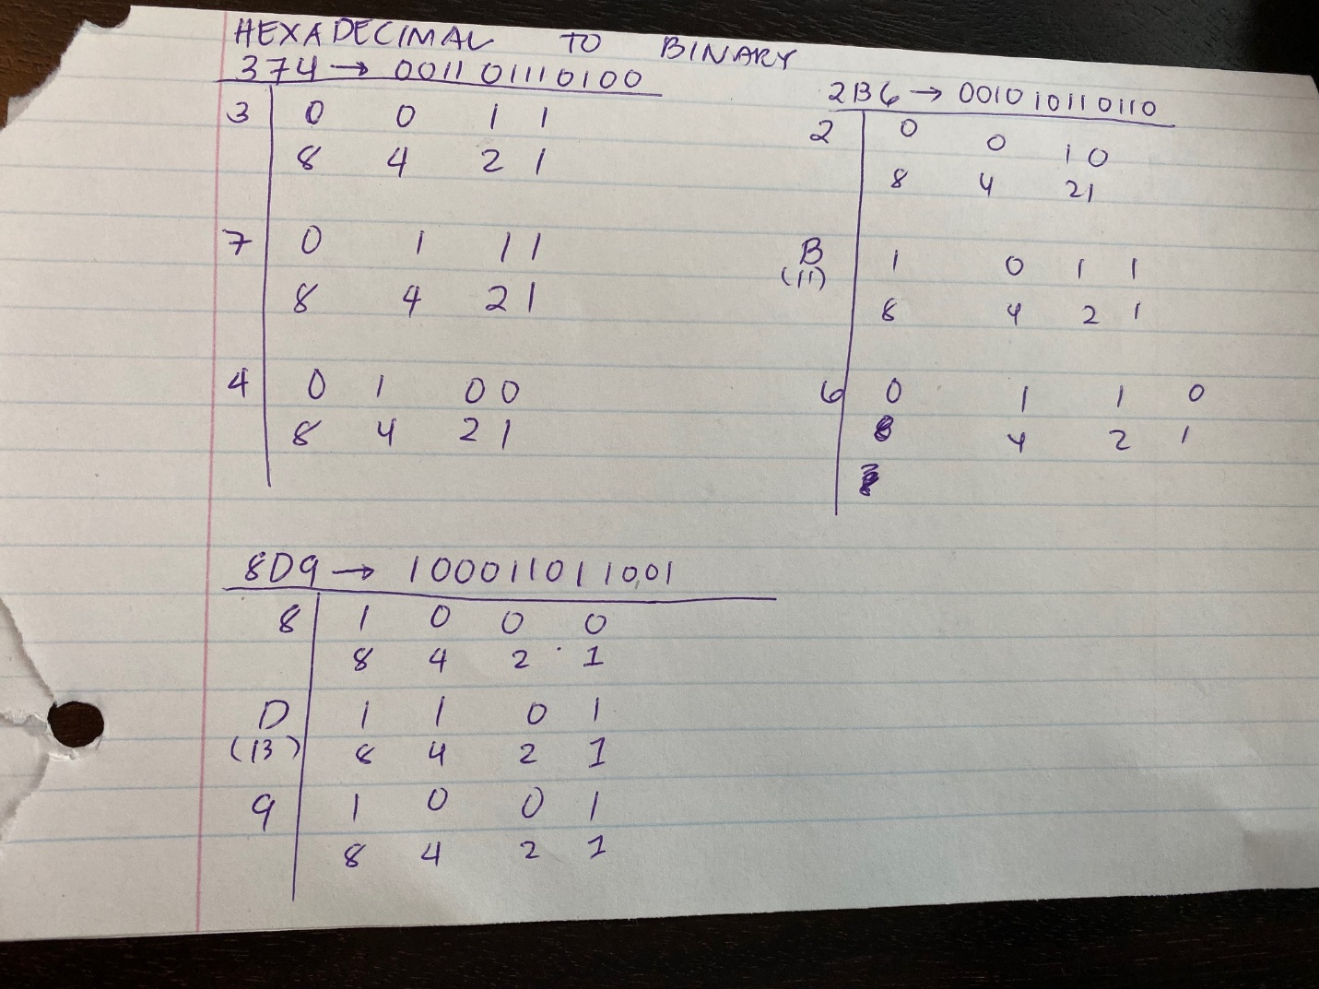

## Decimal to Binary Conversion

(Solutions at the bottom)

**2019**

=011111100011

**378**

=0101111010

**456**

=0111001000

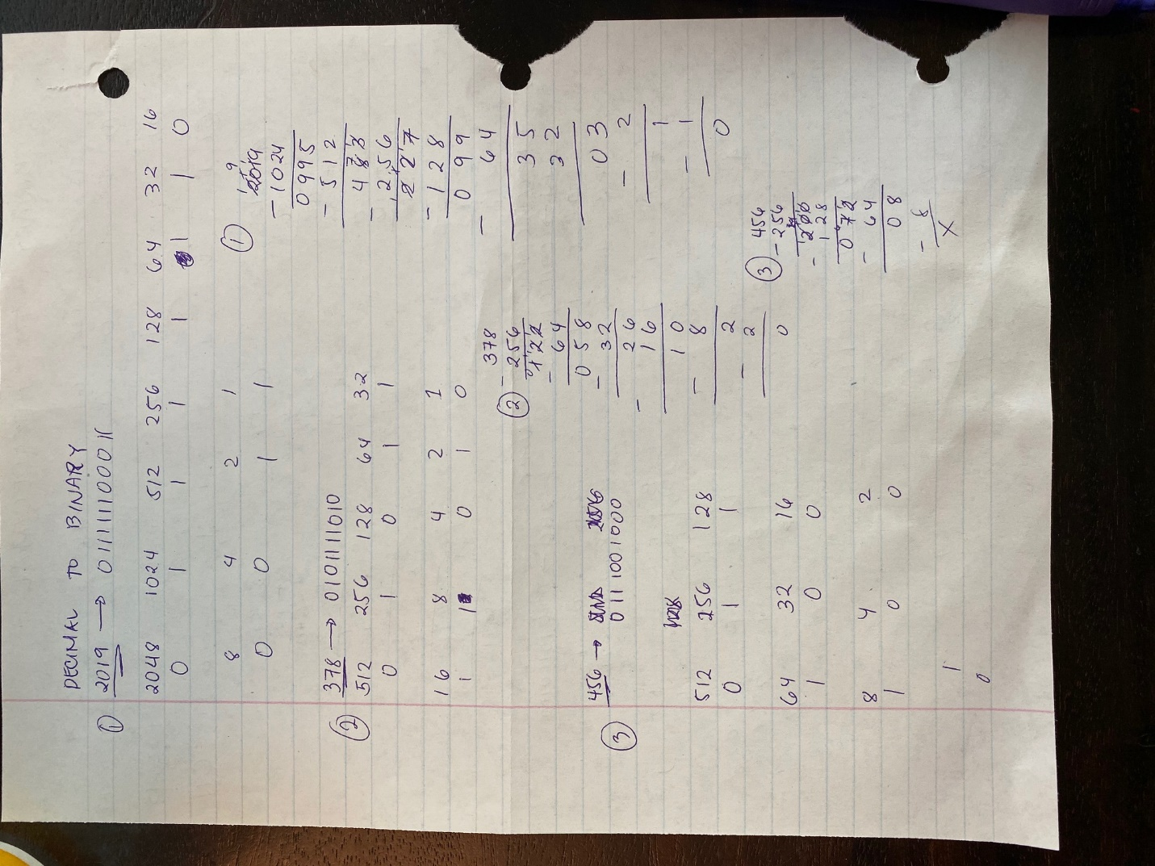

# Question 15

## Cheat Sheet

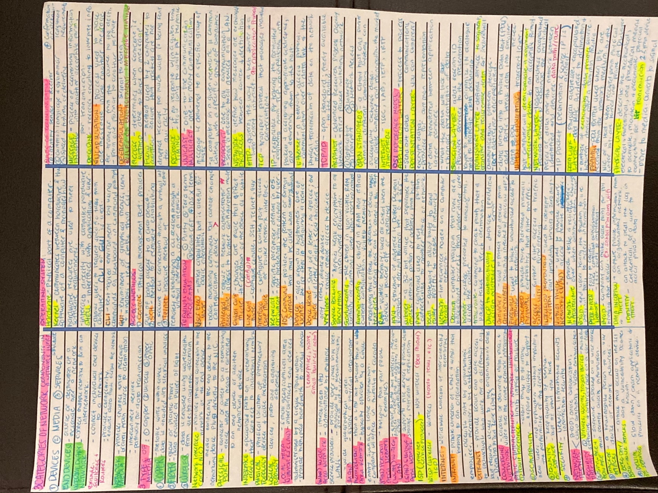

# References

Cisco Networking Academy. (n.d.). *Introduction to Networks, Chapter 2: Configure a Network Operating System*. Retrieved October 10, 2019, from Cisco Networking Academy: https://static-course-assets.s3.amazonaws.com/ITN6/en/index.html#2

1. (Cisco Networking Academy, n.d.)